A000-Xian-Roman-Fish Ring-Silver-100-325 CE





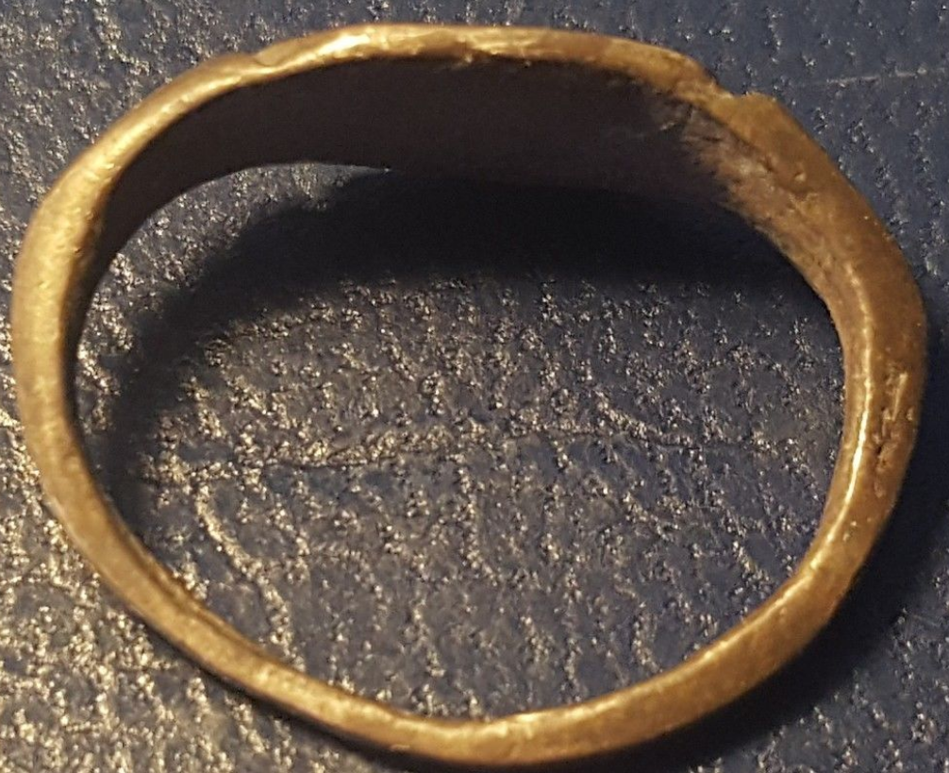

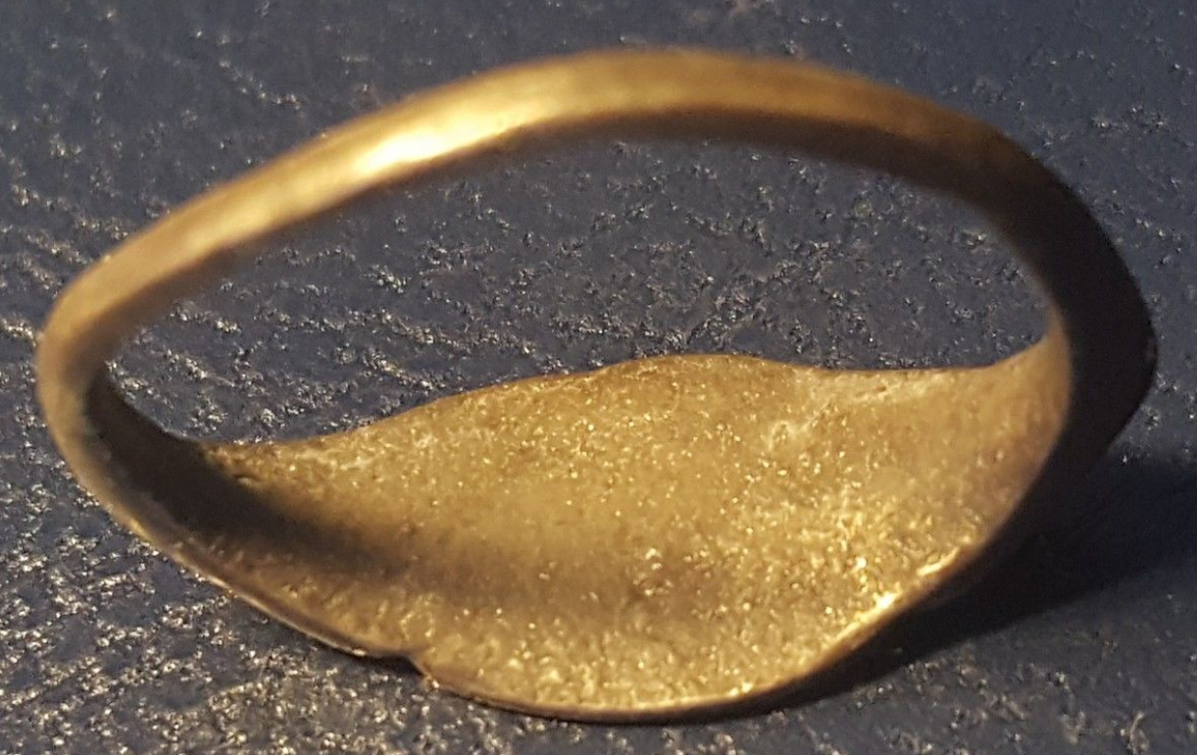

Figs. 1-4. Roman-Fish Ring-Silver-100-325 CE

**Case No.: 4**

**Accession No.**

**Formal Label:** Roman-Fish Ring-Silver-100-325 CE

**Display Description:**

The bezel on this silver ring is dated to 100-325 CE features a fish, which, in Koiné Greek,  [ikʰˈtʰys] is an acronym for "Ἰησοῦς Χριστός, Θεοῦ Υἱός, Σωτήρ" (*Iēsous Christos, Theou Yios, Sōtēr*, which in English is 'Jesus Christ, Son of God, Savior' (see Bull, Lied and Turner 2012: 327). In this ring’s bezel the symbol is elaborated because the artist took extra pains to make it even more obtuse than usual to the casual observer or state authorities by placing three small fist swimming with the larger one. The small fish probably stand for Father, Son and Holy Spirit, an early version of the Christian Trinity. The symbolism of this ring, therefore, represents a further elaboration and obfuscation of the Jesus symbol by inserting a theological addition, which indicates that the doctrine of the Trinity was in process before 325 CE when the fish symbol was no longer needed because in that year Constantine the Great made Christianity a legal religion (see Kelly 1960).

**Accession Number:**

**LC Classification: BT25**

**Date or Time Horizon:** **100-325 CE**

**Geographical Area: Jerusalem**

**Map:**

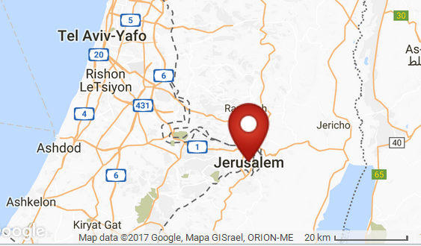

**Fig. 5. Map showing the location of Jerusalem. After Google**

**GPS Coordinates:** 31º46'5.95" N 35º12'49.36" E

**Cultural Affiliation:** Christian

**Geographical Area: Jerusalem**

**Medium:** Silver

**Dimensions**: 22 mm outer, 17 mm inner.

**Weight:** 61 gm, 2 1/8 oz

**Provenance:** Tel Aviv Antiques; Pub: Knell, D. 2004. Cf, Ancient Lamps, RomQ Reference Collection, BSP 12/ Cat. No.

**Condition: original.**In the second-third century CE three sources contributed to the use of the fish symbolism to refer to Jesus in fish symbolic imagery.

The first is the *Sibylline Oracles* that contain a description of the Judgment Day (8.217–250): ΙΗϹΟΥϹ ΧΡΕΙϹΤΟϹ ΘΕΟΥ ΥΙΟϹ ϹΩΤΗΡ ϹΤΑΥΡΟϹ, i.e, “Jesus Christ, God’s Son, Savior, Cross.” The second source is Clement of Alexandria c 200 CE in which he instructs Christians: “Let our seals be the dove, or the fish, or a ship sailing before a fair wind, or the lyre for music, which seal Polycrates used, or a ship’s anchor, which Seleucus carved on his device, and if there be a fisherman, he will recall an apostle and children drawn from the water” (*Paedagogus* 3.11). The third source is Tertullian (c 155 – c. 240) c 225, the Roman Berber in Carthage in the Roman Province of Africa, who uses the Greek word for “fish” in relation to Jesus to explain his symbolism, which reflects its common usage by c 225 CE: “But we little fishes [“*paulo piscibus”*], according to our Fish [“*ΙΧΘΥΝ”*] Jesus Christ, are born in the water [i.e., *in* *baptismo* **]**, nor are we saved in any other manner than by remaining in the water” (*De baptismo* 1).

Christian fish symbolism is reflected in the following inscription from one of the funerary stele from the Roman Catacombs which also reflects its common usage by c 225 CE.

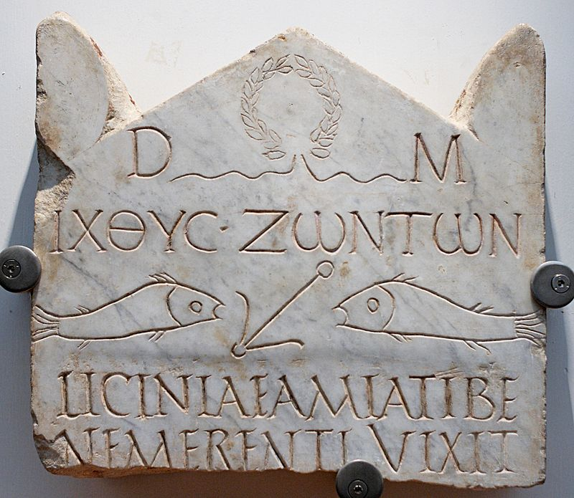

Fig. 6. Funerary stele of Licinia Amias that was originally in one of the Roman catacombs c 225 CE century, Vatican necropolis, Rome, photo c 1993). First register: laurel wreath crown, originally the crown of the victor in Olympic Games but in this context it is a symbol of Christ’s victory over death. The circular crown is made of interlocking laurel branches of the bay laurel (*Laurus nobilis*), an aromatic broadleaf evergreen. The third register is a dedication to the D[is] M[anibus] “the treasures of the ancestors.” The memory of the ancestors was especially revered in Rome, something that must not be violated. The third register IΧΘΥC ΖΩΝΤΩΝ / *Ikhthos zōntōn* ("fish of the living" refers to "Ἰησοῦς Χριστός, Θεοῦ Υἱός, Σωτήρ," *Iēsous Christos, Theou Yios, Sōtēr*, 'Jesus Christ, Son of God, [and] Savior of the living ']). The fourth register is a depiction of two fish and an anchor, signifying IΧΘΥC or Jesus as the anchor of the soul. The Fifth register refers to the interred deceased: “LICINIAE/AMIATI/BE/NEMERENTI/VIXIT” ("Licinia Amiatus [was] well-deserving [when she] lived ..."). Marble, c 225 CE. From the Vatican necropolis, Rome.

**References:**

Kelly, J. N. D. 1960. *Early Christian doctrines*. New York: Harper & Row.

Rasimus, Tuomus. 2012. “Revisiting the ICHTHYS: a suggestion concerning the origins of Christological Fish Symbolism.” In Christian H. Bull, Liv Ingeborg Lied and John D. Turner, eds., Mystery and Secrecy in the Nag Hammadi Collection and Other Ancient Literature: Ideas and Practices. Leiden: Koninklijke Brill.